Welcome to SHAZAM (Double Precision) v11.1 - APR 2015 WIN-NT PAR=112400

...ERROR..DIRECTORY BELOW DOES NOT EXIST:

E:\

...NOTE..CURRENT WORKING DIRECTORY IS: C:\SHAZAM

|_dim rejbeta 1000 sumrejb 1000 **Dim command reserves space for all observations. In other words, it sets up the variables for rejbeta and sumrejb (the rejected beta and the sum of rejected betas).**

|_dim hypoth 21 rejrate 21 **Sets up variables of hypoth and rejrate: the hypothesis and the rejection rate.**

|_set nodoecho nowarn **Suppresses useless output by not printing commands and calculations for every cycle, and eliminates warning signals (respectively)**

|_set maxcolon=1000 **Sets the maximum number of variables in the vector, allowing the program to handle a larger quantity.**

|_?do %=1,21 **Sets a do loop from 1 to 21**

|_?do #=1,1000 **Sets a do loop from 1 to 1000**

|_smpl 1 100 **Signifies that there are 100 observations/a sample size of 100**

|_genr x=nor(1) **Generates a standard normal distribution for variable x.**

|_genr e=nor(1) **Generates a standard normal distribution for variable e.**

|_genr y=2+3*x+e **True distribution of the model. Generate Y given x and e**

|_?ols y x/coef=bols stderr=sols **Gives us an ordinary least squares regression/estimation using y and x. Stores the beta in bols and the standard error in sols. Output suppressed by the question mark**

|_gen1 hypb=(3-((%-1)/100)) **Gen1 command generates a scalar variable or constant. %-1 signifies loop counter minus one, so 0 to 20. In short, this generates the hypothesis from 3 to 2.8 using loops 1-21.**

|_gen1 tbeta=(bols:1-hypb)/sols:1 **Conducts the t-test using the beta coefficient.**

|_gen1 rejbeta:#=dum(abs(tbeta)-1.98) **Finds the rejection of beta using the 1.98 critical value**

|_?endo # **Ends the 1-1000 do loop**

|_smpl 1 1000 **Sets a sample size of 1000**

|_genr sumrejb=sum(rejbeta)**The sum of all captured rejected betas**

|_gen1 hypoth:%=(3-((%-1)/100))**Regenerates the hypothesis from 3 to 2.8 using 1 -21 loops numbers.**

|_gen1 rejrate:%=((sumrejb:1000)/1000) **Calculates the percentage rejection rate for beta using the sum of the rejected betas from our sample size of 1000**

|_?endo % **Ends the 1 to 21 do loop**

|_smpl 1 21 **Sets a sample size of 21.**

|_print hypoth rejrate **Prints out the hypothesis fromn3 to 2.8. Gives the rejection rate at each hypothesis level.**

HYPOTH REJRATE

3.000000 0.5300000E-01

2.990000 0.5800000E-01

2.980000 0.4900000E-01

2.970000 0.6000000E-01

2.960000 0.7800000E-01

2.950000 0.7600000E-01

2.940000 0.8900000E-01

2.930000 0.1190000

2.920000 0.1310000

2.910000 0.1530000

2.900000 0.1730000

2.890000 0.1840000

2.880000 0.2320000

2.870000 0.2580000

2.860000 0.2660000

2.850000 0.3050000

2.840000 0.3290000

2.830000 0.4060000

2.820000 0.4380000

2.810000 0.4610000

2.800000 0.5340000

|_graph rejrate hypoth **Graphs hypothesis and rejection rate on the same graph**

REQUIRED MEMORY IS PAR= 20 CURRENT PAR= 112400

21 OBSERVATIONS

...NOTE..SHAZAM WILL NOW MAKE A PLOT FOR YOU

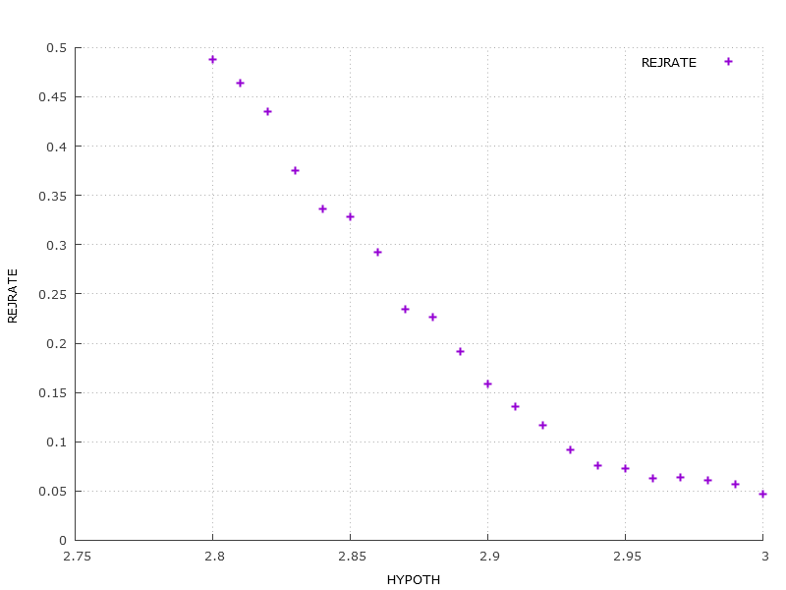

**2. Cauchy**

Welcome to SHAZAM (Double Precision) v11.1 - APR 2015 WIN-NT PAR=112400

...NOTE..CURRENT WORKING DIRECTORY IS: E:\

|_dim rejbeta 1000 sumrejb 1000

|_dim hypoth 21 rejrate 21

|_set nodoecho nowarn

|_set maxcolon=1000

|_?do %=1,21

|_?do #=1,1000

|_smpl 1 100

|_genr x=nor(1)

|_genr e=(nor(1)/abs(nor(1)))

|_genr y=2+3*x+e

|_?ols y x/coef=bols stderr=sols

|_gen1 hypb=(3-((%-1)/100))

|_gen1 tbeta=(bols:1-hypb)/sols:1

|_gen1 rejbeta:# = dum(abs(tbeta)-1.98)

|_?endo #

|_smpl 1 1000

|_genr sumrejb=sum(rejbeta)

|_gen1 hypoth:%=(3-((%-1)/100))

|_gen1 rejrate:%=((sumrejb:1000)/1000)

|_?endo %

|_smpl 1 21

|_print hypoth rejrate

HYPOTH REJRATE

3.000000 0.6000000E-01

2.990000 0.5400000E-01

2.980000 0.5300000E-01

2.970000 0.5700000E-01

2.960000 0.4600000E-01

2.950000 0.4700000E-01

2.940000 0.5200000E-01

2.930000 0.5900000E-01

2.920000 0.5200000E-01

2.910000 0.6200000E-01

2.900000 0.5200000E-01

2.890000 0.5300000E-01

2.880000 0.4900000E-01

2.870000 0.5400000E-01

2.860000 0.5400000E-01

2.850000 0.5200000E-01

2.840000 0.6300000E-01

2.830000 0.5200000E-01

2.820000 0.5800000E-01

2.810000 0.5700000E-01

2.800000 0.5900000E-01

|_graph rejrate hypoth

REQUIRED MEMORY IS PAR= 20 CURRENT PAR= 112400

21 OBSERVATIONS

...NOTE..SHAZAM WILL NOW MAKE A PLOT FOR YOU

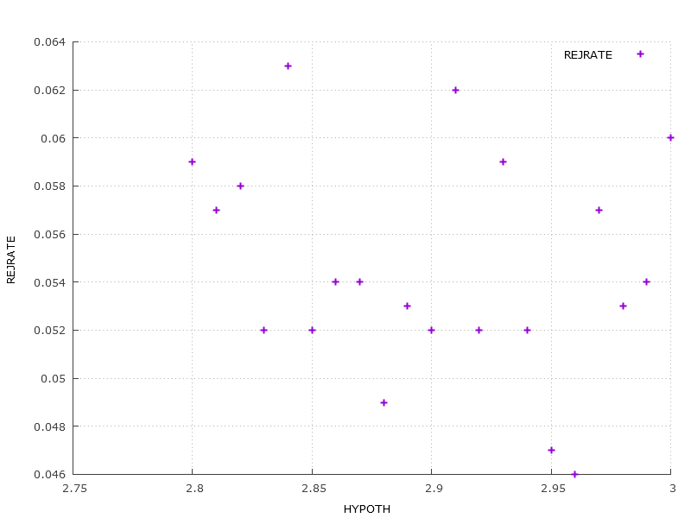

**When using a Cauchy distribution for variable e, it is impossible to differentiate between what is true and what is false. The rejection rates between 2.8 and 3.0 are just too variable.**

**3. N of 25:**

Welcome to SHAZAM (Double Precision) v11.1 - APR 2015 WIN-NT PAR=112400

...NOTE..CURRENT WORKING DIRECTORY IS: E:\

|_dim rejbeta1 10000 sumrejb1 10000 rejbeta2 10000 sumrejb2 10000

|_dim hypoth 21 rejrate1 21 rejrate2 21

|_set nodoecho nowarn

|_set maxcolon=10000

|_?do %=1,21

|_?do #=1,10000

|_smpl 1 25

|_genr x=nor(1)

|_genr tukey=nor(1)

|_genr p=uni(1)

|_if(p.lt.0.05) tukey=nor(10)

|_*

|_*Here's the first regression and the hypothesis testing

|_*

|_genr y1=2+3*x+tukey

|_?stat tukey/stdev=s

|_genr norm=nor(s)

|_genr y2=2+3*x+norm

|_?ols y1 x/coef=bols stderr=sols

|_gen1 hypb=(3-((%-1)/100))

|_gen1 tbeta=(bols:1-hypb)/sols:1

|_gen1 rejbeta1:# = dum(abs(tbeta)-2.06)

|_*

|_*Here's the second regression and the hypotheiss

|_*

|_?ols y2 x/coef=bols stderr=sols

|_gen1 tbeta=(bols:1-hypb)/sols:1

|_gen1 rejbeta2:#=dum(abs(tbeta)-2.06)

|_?endo #

|_smpl 1 10000

|_genr sumrejb1=sum(rejbeta1)

|_gen1 hypoth:%=(3-((%-1)/100))

|_gen1 rejrate1:%=((sumrejb1:10000)/10000)

|_genr sumrejb2=sum(rejbeta2)

|_gen1 rejrate2:%=((sumrejb2:10000)/10000)

|_?endo %

|_smpl 1 21

|_print hypoth rejrate1 rejrate2

HYPOTH REJRATE1 REJRATE2

3.000000 0.4920000E-01 0.5230000E-01

2.990000 0.5140000E-01 0.5030000E-01

2.980000 0.5110000E-01 0.5160000E-01

2.970000 0.5190000E-01 0.5010000E-01

2.960000 0.5600000E-01 0.5610000E-01

2.950000 0.5460000E-01 0.5660000E-01

2.940000 0.5690000E-01 0.5680000E-01

2.930000 0.6090000E-01 0.5810000E-01

2.920000 0.5800000E-01 0.5850000E-01

2.910000 0.6250000E-01 0.6310000E-01

2.900000 0.6570000E-01 0.6290000E-01

2.890000 0.7050000E-01 0.7040000E-01

2.880000 0.7320000E-01 0.6860000E-01

2.870000 0.6770000E-01 0.7510000E-01

2.860000 0.8320000E-01 0.7770000E-01

2.850000 0.8030000E-01 0.8840000E-01

2.840000 0.8670000E-01 0.8430000E-01

2.830000 0.9400000E-01 0.9400000E-01

2.820000 0.9330000E-01 0.9600000E-01

2.810000 0.9730000E-01 0.1031000

2.800000 0.1005000 0.1095000

|_graph rejrate1 rejrate2 hypoth

REQUIRED MEMORY IS PAR= 317 CURRENT PAR= 112400

21 OBSERVATIONS

...NOTE..SHAZAM WILL NOW MAKE A PLOT FOR YOU

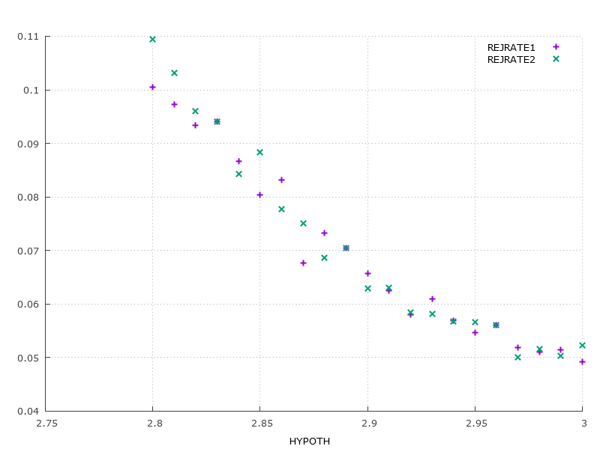

**N of 400**

Welcome to SHAZAM (Double Precision) v11.1 - APR 2015 WIN-NT PAR=112400

...NOTE..CURRENT WORKING DIRECTORY IS: E:\

|_dim rejbeta1 10000 sumrejb1 10000 rejbeta2 10000 sumrejb2 10000

|_dim hypoth 21 rejrate1 21 rejrate2 21

|_set nodoecho nowarn

|_set maxcolon=10000

|_?do %=1,21

|_?do #=1,10000

|_smpl 1 400

|_genr x=nor(1)

|_genr tukey=nor(1)

|_genr p=uni(1)

|_if(p.lt.0.05) tukey=nor(10)

|_*

|_*Here's the first regression and the hypothesis testing

|_*

|_genr y1=2+3*x+tukey

|_?stat tukey/stdev=s

|_genr norm=nor(s)

|_genr y2=2+3*x+norm

|_?ols y1 x/coef=bols stderr=sols

|_gen1 hypb=(3-((%-1)/100))

|_gen1 tbeta=(bols:1-hypb)/sols:1

|_gen1 rejbeta1:# = dum(abs(tbeta)-1.98)

|_*

|_*Here's the second regression and the hypotheiss

|_*

|_?ols y2 x/coef=bols stderr=sols

|_gen1 tbeta=(bols:1-hypb)/sols:1

|_gen1 rejbeta2:#=dum(abs(tbeta)-1.98)

|_?endo #

|_smpl 1 10000

|_genr sumrejb1=sum(rejbeta1)

|_gen1 hypoth:%=(3-((%-1)/100))

|_gen1 rejrate1:%=((sumrejb1:10000)/10000)

|_genr sumrejb2=sum(rejbeta2)

|_gen1 rejrate2:%=((sumrejb2:10000)/10000)

|_?endo %

|_smpl 1 21

|_print hypoth rejrate1 rejrate2

HYPOTH REJRATE1 REJRATE2

3.000000 0.4710000E-01 0.4970000E-01

2.990000 0.4550000E-01 0.4900000E-01

2.980000 0.5340000E-01 0.5060000E-01

2.970000 0.5480000E-01 0.5770000E-01

2.960000 0.6220000E-01 0.6370000E-01

2.950000 0.7160000E-01 0.6790000E-01

2.940000 0.8050000E-01 0.7850000E-01

2.930000 0.8990000E-01 0.8950000E-01

2.920000 0.1044000 0.1070000

2.910000 0.1200000 0.1177000

2.900000 0.1346000 0.1311000

2.890000 0.1496000 0.1524000

2.880000 0.1728000 0.1761000

2.870000 0.1945000 0.1975000

2.860000 0.2239000 0.2287000

2.850000 0.2387000 0.2464000

2.840000 0.2743000 0.2752000

2.830000 0.2939000 0.3017000

2.820000 0.3243000 0.3345000

2.810000 0.3693000 0.3657000

2.800000 0.3876000 0.3941000

|_graph rejrate1 rejrate2 hypoth

REQUIRED MEMORY IS PAR= 335 CURRENT PAR= 112400

21 OBSERVATIONS

...NOTE..SHAZAM WILL NOW MAKE A PLOT FOR YOU

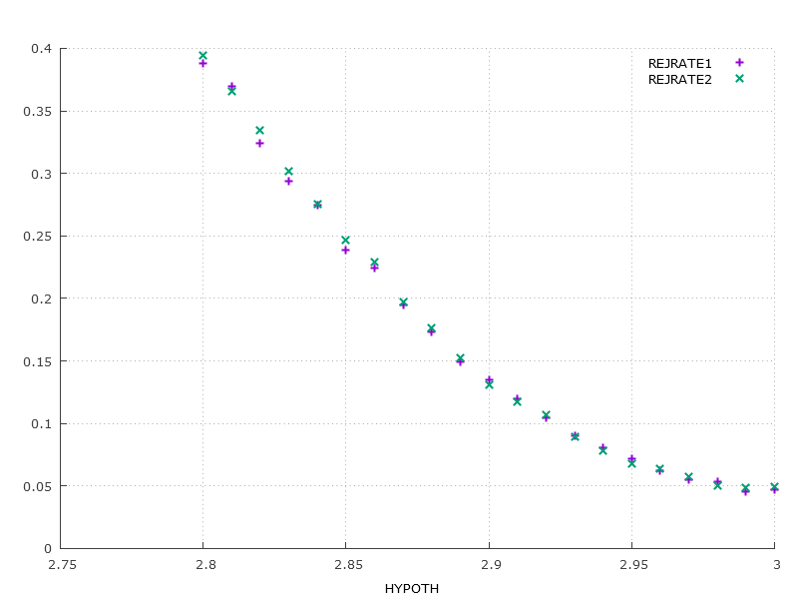

**4. N of 25**

Welcome to SHAZAM (Double Precision) v11.1 - APR 2015 WIN-NT PAR=112400

...NOTE..CURRENT WORKING DIRECTORY IS: E:\

|_dim rejbeta1 10000 sumrejb1 10000 rejbeta2 10000 sumrejb2 10000

|_dim hypoth 21 rejrate1 21 rejrate2 21

|_set nodoecho nowarn

|_set maxcolon=10000

|_?do %=1,21

|_?do #=1,10000

|_smpl 1 25

|_genr x=nor(1)

|_genr tukey=nor(1)

|_genr p=uni(1)

|_if(p.lt.0.05) tukey=nor(10)

|_*

|_*Here's the first regression and the hypothesis testing

|_*

|_genr y1=2+3*x+tukey

|_?stat tukey/stdev=s

|_?ols y1 x/coef=bols stderr=sols

|_gen1 hypb=(3-((%-1)/100))

|_gen1 tbeta=(bols:1-hypb)/sols:1

|_gen1 rejbeta1:# = dum(abs(tbeta)-2.06)

|_*

|_*Here's the second regression and the hypotheiss

|_*

|_?robust y1 x/coef=btrim stderr=strim trim=.2

|_gen1 tbeta=(btrim:1-hypb)/strim:1

|_gen1 rejbeta2:#=dum(abs(tbeta)-2.06)

|_?endo #

|_smpl 1 10000

|_genr sumrejb1=sum(rejbeta1)

|_gen1 hypoth:%=(3-((%-1)/100))

|_gen1 rejrate1:%=((sumrejb1:10000)/10000)

|_genr sumrejb2=sum(rejbeta2)

|_gen1 rejrate2:%=((sumrejb2:10000)/10000)

|_?endo %

|_smpl 1 21

|_print hypoth rejrate1 rejrate2

HYPOTH REJRATE1 REJRATE2

3.000000 0.5000000E-01 0.8060000E-01

2.990000 0.4960000E-01 0.8110000E-01

2.980000 0.5430000E-01 0.8180000E-01

2.970000 0.4920000E-01 0.7940000E-01

2.960000 0.5220000E-01 0.8870000E-01

2.950000 0.5770000E-01 0.8700000E-01

2.940000 0.5630000E-01 0.9080000E-01

2.930000 0.5720000E-01 0.9240000E-01

2.920000 0.6510000E-01 0.1012000

2.910000 0.6040000E-01 0.1002000

2.900000 0.6020000E-01 0.1028000

2.890000 0.6790000E-01 0.1079000

2.880000 0.7000000E-01 0.1109000

2.870000 0.7230000E-01 0.1178000

2.860000 0.7580000E-01 0.1256000

2.850000 0.8150000E-01 0.1368000

2.840000 0.8160000E-01 0.1346000

2.830000 0.8690000E-01 0.1443000

2.820000 0.9720000E-01 0.1619000

2.810000 0.9720000E-01 0.1544000

2.800000 0.1058000 0.1644000

|_graph rejrate1 rejrate2 hypoth

REQUIRED MEMORY IS PAR= 317 CURRENT PAR= 112400

21 OBSERVATIONS

...NOTE..SHAZAM WILL NOW MAKE A PLOT FOR YOU

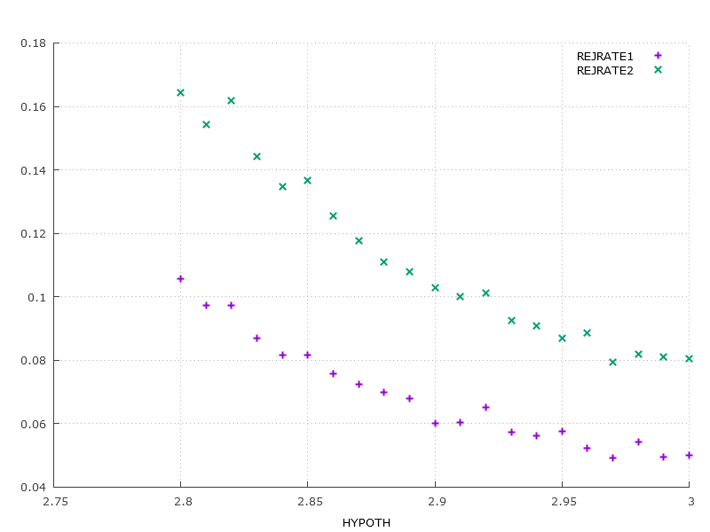

**N of 400**

Welcome to SHAZAM (Double Precision) v11.1 - APR 2015 WIN-NT PAR=112400

...NOTE..CURRENT WORKING DIRECTORY IS: E:\

|_dim rejbeta1 10000 sumrejb1 10000 rejbeta2 10000 sumrejb2 10000

|_dim hypoth 21 rejrate1 21 rejrate2 21

|_set nodoecho nowarn

|_set maxcolon=10000

|_?do %=1,21

|_?do #=1,10000

|_smpl 1 400

|_genr x=nor(1)

|_genr tukey=nor(1)

|_genr p=uni(1)

|_if(p.lt.0.05) tukey=nor(10)

|_*

|_*Here's the first regression and the hypothesis testing

|_*

|_genr y1=2+3*x+tukey

|_?stat tukey/stdev=s

|_?ols y1 x/coef=bols stderr=sols

|_gen1 hypb=(3-((%-1)/100))

|_gen1 tbeta=(bols:1-hypb)/sols:1

|_gen1 rejbeta1:# = dum(abs(tbeta)-1.98)

|_*

|_*Here's the second regression and the hypotheiss

|_*

|_?robust y1 x/coef=btrim stderr=strim trim=.2

|_gen1 tbeta=(btrim:1-hypb)/strim:1

|_gen1 rejbeta2:#=dum(abs(tbeta)-1.98)

|_?endo #

|_smpl 1 10000

|_genr sumrejb1=sum(rejbeta1)

|_gen1 hypoth:%=(3-((%-1)/100))

|_gen1 rejrate1:%=((sumrejb1:10000)/10000)

|_genr sumrejb2=sum(rejbeta2)

|_gen1 rejrate2:%=((sumrejb2:10000)/10000)

|_?endo %

|_smpl 1 21

|_print hypoth rejrate1 rejrate2

HYPOTH REJRATE1 REJRATE2

3.000000 0.4730000E-01 0.4930000E-01

2.990000 0.4620000E-01 0.5000000E-01

2.980000 0.5280000E-01 0.6410000E-01

2.970000 0.5300000E-01 0.8090000E-01

2.960000 0.6380000E-01 0.1032000

2.950000 0.6630000E-01 0.1358000

2.940000 0.8130000E-01 0.1747000

2.930000 0.9060000E-01 0.2175000

2.920000 0.9770000E-01 0.2750000

2.910000 0.1140000 0.3399000

2.900000 0.1348000 0.4009000

2.890000 0.1525000 0.4788000

2.880000 0.1751000 0.5389000

2.870000 0.1979000 0.6115000

2.860000 0.2191000 0.6795000

2.850000 0.2445000 0.7415000

2.840000 0.2757000 0.7875000

2.830000 0.2966000 0.8413000

2.820000 0.3284000 0.8717000

2.810000 0.3598000 0.9042000

2.800000 0.3963000 0.9296000

|_graph rejrate1 rejrate2 hypoth

REQUIRED MEMORY IS PAR= 329 CURRENT PAR= 112400

21 OBSERVATIONS

...NOTE..SHAZAM WILL NOW MAKE A PLOT FOR YOU

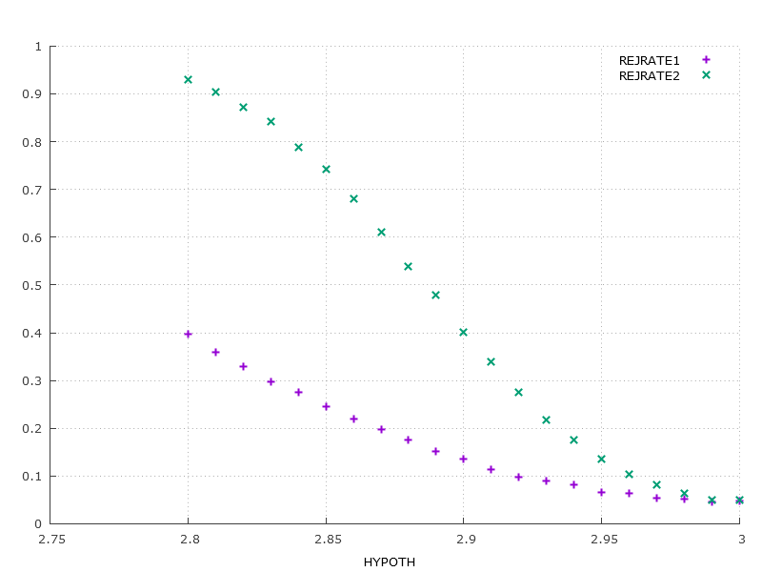

1. **It would appear that using a robust standard error is more accurate than a 20% trim for higher quanties.**
2. **The larger the sample, the quicker rejection rate 2 falls.**